# JS Advanced: Exam 18 March 2018

Problems for exam preparation for the [“JavaScript Advanced” course @ SoftUni](https://softuni.bg/courses/javascript-advanced). Submit your solutions in the SoftUni judge system at <https://judge.softuni.bg/Contests/974/>.

# Problem 1. Restaurant Bill (Simple DOM Interaction)

You are given the following **HTML code**:

|  |
| --- |
| restaurant-bill.html |
| <!DOCTYPE **html**>  <**html lang="en"**>  <**head**>  <**meta charset="UTF-8"**>  <**title**>Restaurant Bill</**title**>  <**style**>  **body** {**padding**: 30**px**;}  **table**, **section** {**border**: 1**px solid black**; **border-collapse**: **collapse**;}  **th**, **td** {**padding**: 5**px** 20**px**;}  **th**, **tfoot td** {**background**: **#cccccc**;}  **tr**:**nth-child**(**odd**) {**background**: **#eeeeee**;}  **tr**:**nth-child**(**even**) {**background**: **#dddddd**;}  **tfoot** > **tr td** {**font-style**: **italic**; **font-weight**: **bold**;}  **section** {**margin-top**: 10**px**; **width**: 177**px**; **background**: **#cccccc**;}  **section** > **\*** {**display**: **block**; **padding**: 5**px**;}  **h3** {**margin**: 0; **text-align**: **center**;}  **button** {**margin**: 5**px auto**;}  </**style**>  <**script src="https://code.jquery.com/jquery-3.3.1.min.js"**></**script**>  </**head**>  <**body**>  <**h2**>Restaurant Bill</**h2**>  <**table id="bill"**>  <**thead**>  <**tr**>  <**th**>Product</**th**>  <**th**>Price</**th**>  </**tr**>  </**thead**>  <**tbody id="product-list"**></**tbody**>  <**tfoot**>  <**tr**>  <**td**>Total:</**td**>  <**td**>0.00</**td**>  </**tr**>  </**tfoot**>  </**table**>  <**section id="add-product"**>  <**h3**>Add new product</**h3**>  <**label**>Product:  <**input type="text"**>  </**label**>  <**label**>Price:  <**input type="number"**>  </**label**>  <**button onclick="***addProduct*()**"**>Add</**button**>  </**section**>  <**script**>  **function** *addProduct*() {  ***// TODO***  }  </**script**>  </**body**>  </**html**> |

### Your Task

**Write the missing JavaScript function** addProduct() to make the **[Add]** button work as expected – when clicked **adds** the new product’s information to the restaurant bill. The **[Add]** button should:

* **Append** the **text** received from the **input boxes** as a **new** **row at the end** of the **table’s body**
* **Add** the **new** **product’s price** to the **total** sum
* **Clear** the **input boxes** after the **product’s information** is **submitted**
* **Do nothing** if **either** of **text boxes** is **empty**

### Submission

Submit only your addProduct function.

***Scroll down for examples.***

### Examples

**First example:**

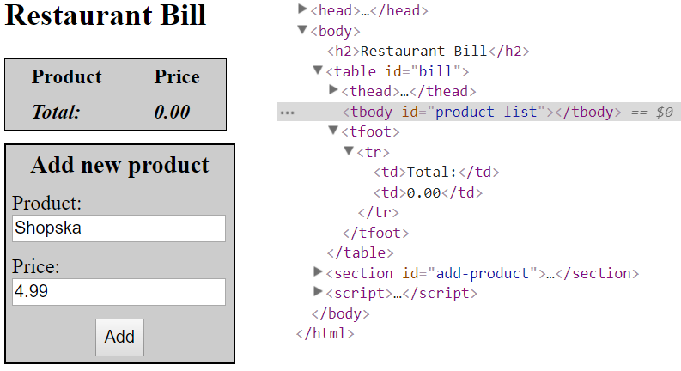

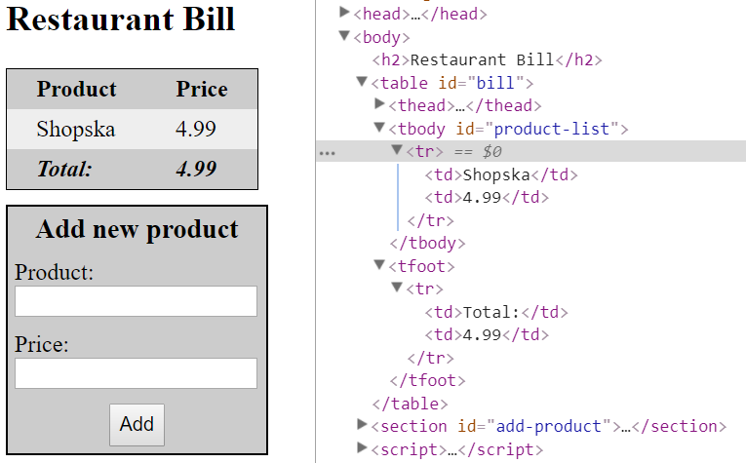

**Scroll down** for more examples.

**Second example:**

